**CS 1632 – DELIVERABLE 2: Unit Testing CitySim9006**

**Joshua Kephart**

**Github: jak243**

**Repository URL:** [**https://github.com/jak243/CS1632_d2.git**](https://github.com/jak243/CS1632_d2.git)

Unit tests can be run using $ruby citysim_test.rb

This was somewhat challenging as it was my first try at writing Ruby. I feel like I likely missed a lot of standard practice mistakes. Also, I probably wrote the Ruby code like it was Java code. The program itself wasn’t very difficult, but the testing wasn’t always intuitive. I think did not make the code modular enough. I would like to be able to cover more of the functionality of the code with the unit tests in the future. One thing that threw me off for a little while was how to make a good mock. Then I also was wondering how to make a mock and then have another mock return that mock in a stub but also still be able to assert_equal with that same mock. I eventually “solved this” by making a mock be a class variable. This felt very hacky to me and probably wrong, but I started too late to do anything about it definitely so I left it in. (first time is line 268 of citysim_test.rb)

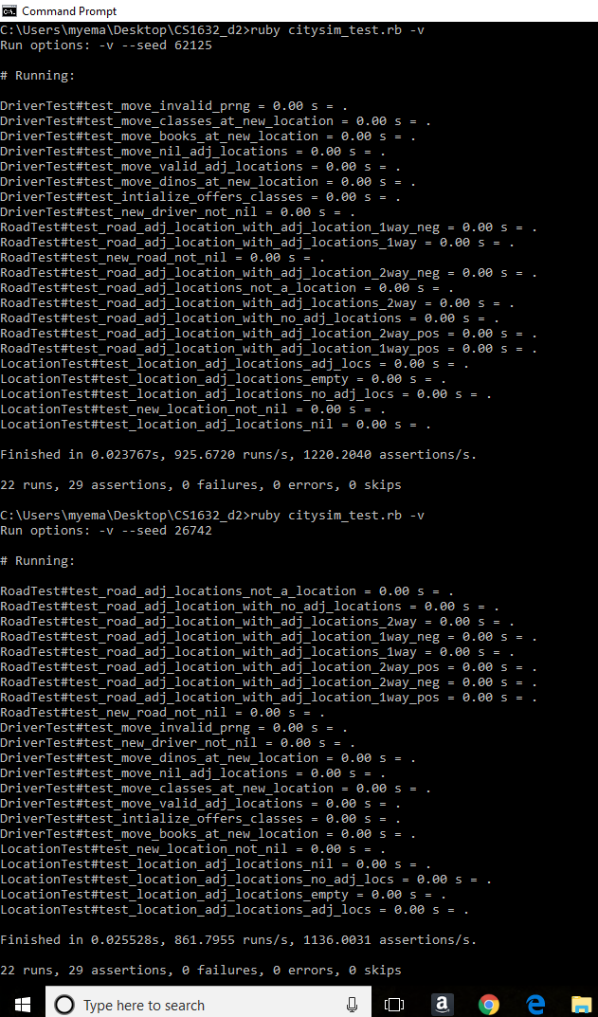Screenshots of unit tests